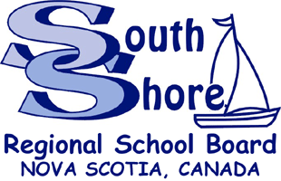

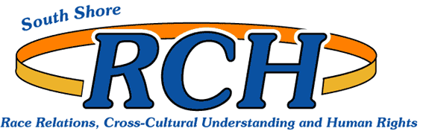

April 16, 2015

Dear Guardians and Parents:

In effort to promote cultural awareness and equitable education within the South Shore Regional School Board (SSRSB) the Student Support Worker program is going into its 10th year. The Student Support Worker program is part of Race Relations, Cross Cultural Understanding and Human Rights (RCH) Division of SSRSB. The primary role of a Student Support Workers is to provide support for students and their families in effort make schooling a positive experience and ensure students remain in school and achieve educational success. The Student Support Workers primarily works with students who self-identified as of Aboriginal and/or African descent; however, it is understood and noted that the education Student Support Workers provide is valuable and needed for all school members of our community. Student Support Workers do offer classroom presentations and work with educators in educating all members of the school community in anti-racism education and cultural awareness.

The Student Support Workers are as follows:

Name | Home School (Area) | Contact Information
Corbin Hatt | ParkView Education Centre | 902-521-9812
Shelly Whynot | Dr.J.C. Wickwire | 902-350-2880
Sheila Porter | Chester District Elementary | 902-521-3314
Teresa Provo | North Queens Community | 902-521-9329

For additional information on the Student Support Worker program please see the attached brochure. If your student is interested in participating in the Student Support Worker program please complete the attached permission slip form and return it to your student’s school. The Student Support Worker in your area will contact you and your students in regards to activities and initiatives that he/she may participate in.

Respectfully yours,

Lamar Eason
Coordinator of Race Relations,
Cross Cultural Understanding, &
Human Rights
902-521-3449

Student Support Worker Program
Permission Slip Form

The Student Support Worker program is for students who self-identify as Aboriginal or African descent. Your student may enroll in the program if she/ he self-identifies as African or Aboriginal/First Nations descent.
Please Print:
Student Information

Name of Student: ________________________________ Student Support Workers Name: ______________________

School: ___________________________ Homeroom Teacher: ______________________ Grade: _______

Address of Student: ________________________________________________________________________________

Phone: __________________ Email (if applicable): _____________________________________________________

Self- Identification
Please indicate if you are:
Female Male

*of African descent *of Aboriginal descent

** For the purpose of this form, African Descent people are persons who consider themselves to be African-Canadian, African-American, African-Caribbean and African. Aboriginal people are persons who consider themselves to be North American First Nations, Inuit or Metis.

Parent/Guardian Information

Name(s) of Parent/ Guardian: ___________________________________

Work Phone: ________________________ Home Phone: ________________________

Emergency Information
In the event of an emergency and no one can be contacted at the numbers listed above, whom should we call?

Name: ____________________________________________ Relationship: ________________________________

Telephone: ________________________

Family Physician Name: ______________________________ Telephone: ___________________

Nova Scotia Health Insurance Number:____________________________

I give permission for my son/daughter to participate in the Student Support Worker Program for the 2014-2015 school year. In the event of an emergency (medical or dental) I give permission for treatment of my student. I understand that I will be contacted first in such an emergency, if possible.

Guardian/ Parent Signature: ____________________________________ Date: ________________________

Student’s Signature: __________________________________________ Date: ________________________

