School Options Committee
Requests for Information from Staff

November 26, 2015 Meeting

- Was there any consistency among the principals with when and how they completed their profile sheets? Was there a consistent message?
The individual school profile sheets are a template provided by the province as part of the School Review Policy (page 41).

Completion of the templates for this school review involved Board staff from Operations, Finance, Human Resources, and Programs and Student Services Departments, as well as principals from all schools involved in the review.

The profile sheets were populated in a consistent manner with applicable sections being completed by Board staff, then sent to principals for review and completion of program and unique school information. Following completion of the profiles by principals, a final review was conducted by phone between each school principal and Operations to validate all data.

- How are projected enrolments established?
Enrolments are pulled directly from the Long Range Outlook Glossary. Enrolment projections for Grades 1 through 12 are calculated by moving forward the previous year’s enrolment in the previous grade level. Primary projections are calculated based on using the average grade size of the Primary through Grade 2 numbers at the school from the previous year. On a go-forward basis, all boards in the province will be using a standardized method of calculating projected enrolments; this will be done using the software Baragar.

- Numbers in classrooms/courses to verify how many classes are split?
Refer to spreadsheets “School Course Offerings by Section PLUS Correspondence and NSVS” (several school years).

- What courses have been lost in each school and what might be lost if no action is taken by the committee?
Refer to spreadsheets “School Course Comparison” (several school years).

- How many drop a virtual course? How many virtual courses are taken in a year and what is the success rate of these courses? What is available at NSVS?
The present online registration system for NSVS opens up for the upcoming school year around April 1 and normally remains open until about two weeks into a given semester. Unfortunately, they cannot distinguish between a student “dropping” a course on May 30, versus September 30, versus October 30, except possibly at the school level. In other words, the data on students who “complete” NSVS courses is somewhat ambiguous. Success or lack of success in a course would be based on the student being in the course until at least after the mid-semester reporting period in each semester. If one considers a lack of success being a student who drops the course mid-October, then the actual numbers provided are more favourable than what they would actually be.

Refer to spreadsheets “School Course Offerings by Section PLUS Correspondence and NSVS” (several school years).

- As above, for correspondence courses?
For correspondence studies, they base success or lack of success on course completion within the given deadline for students whose course has been paid for. Knowing this, and the circumstances of some students who take courses via correspondence, the rates of success are always very low.

Refer to spreadsheets “School Course Offerings by Section PLUS Correspondence and NSVS” (several school years).

- Parking – impact on both schools, as well as impact on students and staff?
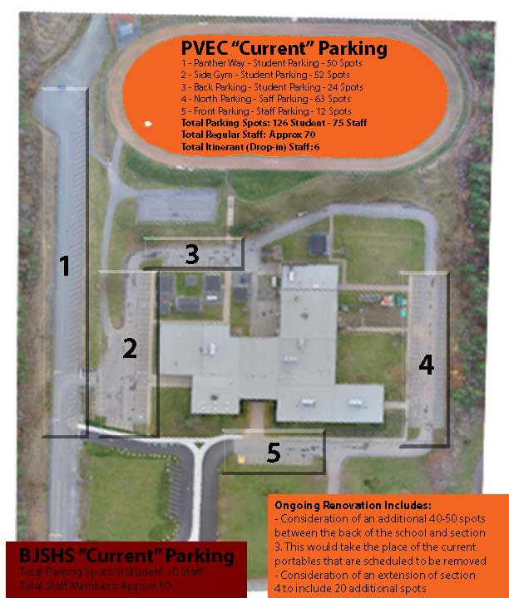

- Bussing – number of students on busses arriving at Park View?
Currently, the SSRSB is required to accommodate all PVEC students whether they use the bus or not. The NS Education Act states that any students who live more than 3.6km from the school must have access to student transportation. Currently, PVEC does not have any students who the SSRSB would consider “Walking Students” (students who live within 3.6 kilometers of the school that have access to sidewalks, crosswalks, and proper pedestrian markings). This means all students are currently considered busing students. We often get calls from parents of students throughout the year who live in the extremities of the catchment area and require transportation for a couple of days or weeks. We do have to accommodate these requests.

A spot check was completed on December 3 and it was determined that 296 students (42% of registered students) used the bus on that day. Typically, to get a consistent average number a study would be completed over several days, perhaps even a month. There will be a follow up in regards to this number after more daily counts can be completed.

- Map showing colour bands of students living in the areas we are reviewing?
See “Map Grades 10-12 BHS”.

- Is there a cost difference between middle schools and junior high schools?
As referenced in the AMLE middle school philosophy, true middle schools have more focused support for individual students and value a differentiated instruction approach. They also value service-learning opportunities where students partner with the community. These examples do come at an increased cost. The SSRSB currently funds middle grades with this in mind.

The traditional junior high school approach is much less student-centered, in that instruction, assessment, and routines are not supported with current research and much less responsive to motivating and engaging today’s students.

During the 2014-2015 fiscal year and school year, 6.68 full-time equivalents (FTEs) were allocated to Middle Level Programming. This equates to $503,781 on a full-year basis. Middle Level Programming was eliminated in the 2015-2016 budget.

- Any data in regards to having grade 9s move into a 10-12 school?

In what school configuration do grade 9s fit best?
Grade 9 is a unique year in that it really is different from grades six, seven, and eight. It is also different from grades 10-12. The programming at the grade 9 level should reflect this uniqueness. There is little research to suggest that grade 9 programming is better suited attached to a junior high, middle school, or senior high school.

Improving Programming at the Grade 9 Level
Nationally, grade 9 students indicate the lowest level of engagement in school.

(M Fullan; Stratosphere)

Efforts are underway to enhance grade 9 programming in the province of Nova Scotia and across Canada. The 3Rs: Renew, Refocus, Rebuild – Nova Scotia’s Action Plan for Education 2015, references grade 9 specifically with the following action:
“Add more Discovering Opportunities 9 programs in schools across the province to familiarize grade 9 students with careers and education programs linked to trades, technology, and apprenticeship”.

Please see the complete Action Plan through this link:
http://www.ednet.ns.ca/education-actionplan

In 2011, the province of Nova Scotia formed a committee mandated to overhaul and improve grade 9 public school programming. This committee produced a draft document Learning in Action: Project-Based Learning (Grade 9 Pilot) (attached).

The SSRSB also did work in this area, known to us as Inquiry-Based Learning, which involved all grade 9 classes in the Board. There was evidence of increased engagement and learning with this pedagogical approach. There was a cost pressure associated with this initiative, as we provided extra staff to schools so they could create smaller groups of students to pursue interdisciplinary learning, consistent with the Learning in Action document. During the 2015-2016 budget deliberations, it was necessary to remove that extra funding.

What trends are evident in Nova Scotia regarding the school configuration of grade 9 students?
Traditionally, schools were configured as elementary (P-6), Junior High (7-9), and Senior High (10-12). Depending on the population of a given community, configurations may have been P-6 and 7-12, or in a small community P-12.

As the province faces significant enrollment decline, there have been trends occurring. Smaller high schools have been consolidated into larger schools when geographically possible. There are many examples of this occurring over the past 40 plus years. This trend exists because it allows high schools with larger populations to offer a broader range of courses for students while providing fiscal efficiency.

A second trend has occurred more so over the past 20 years, most often after the above consolidation has occurred. As high school populations continue to decline, grade 9s have been relocated to the high school. This grade 9-12 configuration achieves efficiencies in sustaining specialist teachers and economy of scale savings. A second piece to this trend is that junior high schools are being renamed as middle schools.

There is a philosophical difference between the traditional junior high and the middle school approach. All South Shore schools, even those still named junior high schools, have moved significantly along the continuum of middle school practices. When opportunities present, jurisdictions may move their 6s and sometimes 5s to the middle school setting.

See the middle school vision (blue color chart below) from the Association of Middle Level Education (AMLE).
